Attachment 1
Attachment for SET Release xxx/2011 on December 7, 2011

SET-listed companies' performance from Q1/2008-Q3/2011

Unit: THB mln

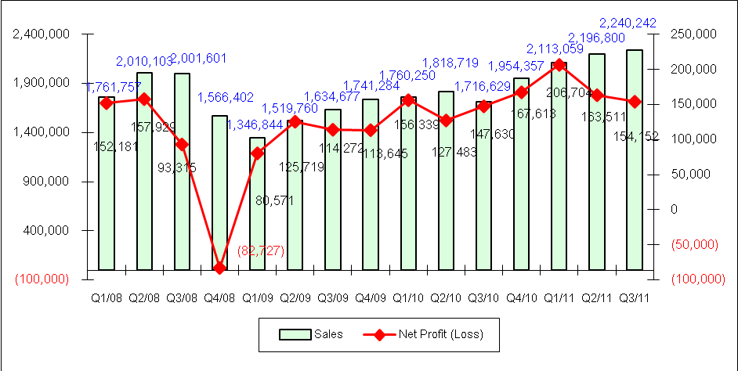

Attachment 2

Net profits of the eight industry groups for the first nine months of 2011 (ended Sept. 30)

Unit: THB mln
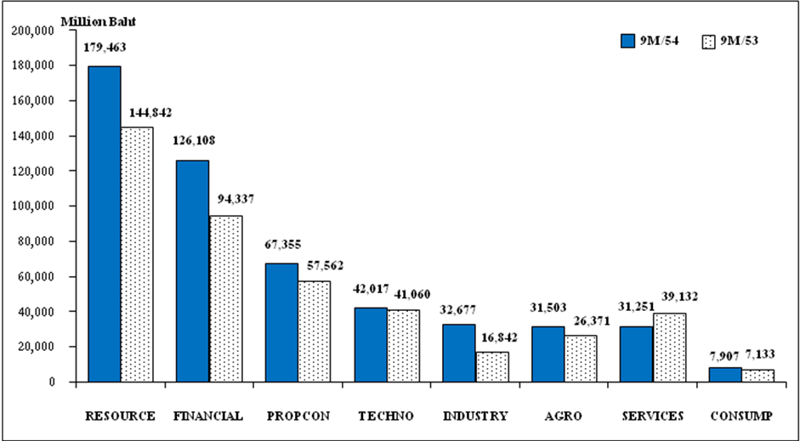

Industry Group | RESOURCE | FINCIAL | PROPCON | TECHNO | INDUSTRY | AGRO | SERVICES | CONSUMP
Net profit  Growth (%) | 23.90 | 33.68 | 17.01 | 2.33 | 94.02 | 19.46 | (20.14) | 10.85

Top Five Most Profitable Sectors for Jan-Sept 2011
(excluding firms in the Non-compliance and Non-performing groups)

Sectors | Net profit (mln baht) |  | Growth  (%) | Net profit per all listed firms (%) | Net profit per industry group (%)
Sectors | 9mth/2011 | 9mth/2010 | Growth  (%) | Net profit per all listed firms (%) | Net profit per industry group (%)
Energy & utilities | 179,300 | 144,433 | 24.14 | 34.43 | 99.91
Banking | 110,240 | 82,234 | 34.06 | 21.17 | 87.42
Construction materials | 39,444 | 27,738 | 42.20 | 7.57 | 58.56
Information &Communication Technology | 36,364 | 31,971 | 13.74 | 6.98 | 86.55
Food and Beverage | 25,941 | 20,555 | 26.20 | 4.98 | 82.34

Attachment 3

The 41 firms listing on the SET and mai whose first-nine-month net profit and sales surpassed their performances in the whole of 2010
 | 33 companies listing on the SET
 | Symbol | Sector | Net profit (mln baht) |  | Sales (mln baht)
 | Symbol | Sector | 9mth/2011 | 12mth/2010 | 9mth/2011 | 12mth/2010
1 | BGH | Health Care Services | 3,495.35 | 2,295.00 | 26,413 | 23,734
2 | BTS | Transportation & Logistics | 1,341.40 | 630.00 | 5,308 | 4,571
3 | BWG | Professional Services | 82.83 | 41.03 | 781 | 713
4 | CIMBT | Banking | 856.00 | 829.00 | 6,668 | 6,452
5 | IVL | Petrochemicals & Chemicals | 17,026.00 | 10,560.00 | 142,762 | 96,858
6 | KBANK | Banking | 21,193.00 | 20,047.00 | 80,356 | 62,740
7 | KSL | Food and Beverage | 1,484.10 | 159.00 | 12,511 | 12,071
8 | KTB | Banking | 16,222.00 | 14,913.00 | 69,734 | 63,072
9 | LANNA | Energy & Utilities | 858.00 | 675.00 | 9,340 | 8,777
10 | LPN | Property Development | 1,855.00 | 1,637.00 | 11,364 | 9,941
11 | MFEC | Information & Communication Technology | 144.95 | 68.00 | 2,875 | 2,547
12 | MILL | Steel | 165.35 | 116.00 | 11,518 | 9,782
13 | MINT | Food and Beverage | 2,408.00 | 1,241.10 | 18,932 | 18,140
14 | MJLF | Property Fund | 359.17 | 296.58 | 347 | 335
15 | P-FCB | Media & Publishing | 58.21 | 55.00 | 309 | 305
16 | PREB | Property Development | 88.00 | 62.00 | 2,491 | 1,933
17 | Q-CON | Construction Materials | 136.24 | 63.00 | 1,335 | 1,186
18 | RASA | Property Development | 144.20 | 114.00 | 906 | 784
19 | SAMTEL | Information & Communication Technology | 638.11 | 406.00 | 8,136 | 5,615
20 | SCB | Banking | 29,535.00 | 24,206.00 | 73,553 | 53,678
21 | SENA | Property Development | 359.13 | 317.00 | 1,890 | 1,247
22 | SIAM | Home & Office Products | 418.49 | 189.00 | 3,704 | 2,864
23 | SST | Transportation & Logistics | 305.13 | 51.00 | 280 | 267
24 | STEC | Property Development | 665.00 | 444.00 | 11,425 | 9,291
25 | SUSCO | Energy & Utilities | 105.00 | 79.00 | 10,551 | 10,485
26 | SYNEX | Information & Communication Technology | 303.48 | 271.00 | 15,799 | 15,600
27 | TCC | Energy & Utilities | 37.00 | 26.00 | 846 | 473
28 | TNITY | Finance & Securities | 80.00 | 39.00 | 493 | 445
29 | TOP | Energy & Utilities | 12,991.00 | 8,999.00 | 336,545 | 318,391
30 | TUF | Food and Beverage | 3,551.00 | 2,874.00 | 72,671 | 71,507
31 | UPOIC | Agribusiness | 317.04 | 123.00 | 1,002 | 825
32 | UST | Transportation & Logistics | 138.41 | 102.00 | 1,062 | 916
33 | UVAN | Agribusiness | 925.55 | 537.00 | 5,116 | 4,311
 | Note: Figures of sales and net profits are adjusted following the calendar year
 | Source: SET
 | Eight companies listing on mai
 | Symbol | Sector | Net profit (mln baht) |  | Sales (mln baht)
 | Symbol | Sector | 9mth/2011 | 12mth/2010 | 9mth/2011 | 12mth/2010
1 | AGE | mai | 198.87 | 127.00 | 4,079 | 2,819
2 | CRANE | mai | 82.64 | 58.00 | 681 | 602
3 | EARTH | mai | 267.26 | 70.78 | 3,301 | 1,770
4 | PYLON | mai | 64.05 | 32.00 | 737 | 626
5 | TSF | mai | 25.79 | 1.49 | 203 | 177
6 | UIC | mai | 33.67 | 17.07 | 416 | 292
7 | UKEM | mai | 134.54 | 82.00 | 2,591 | 2,554
8 | VTE | mai | 16.38 | 15.77 | 421 | 356
 | Note: Figures of sales and net profits are adjusted following the calendar year

